PH126 Logic I Fast Lecture 4
Lecturer: s.butterfill@warwick.ac.uk

Truth table for →
Assuming that the rules of Fitch are such that it is impossible to prove an argument which is not logically valid, the truth-table for → is fixed if we accept →Elim and →Intro.
How do the rules of proof for → fix its truth table?
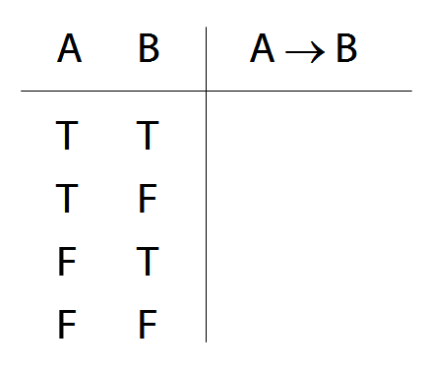

‘If’ and →
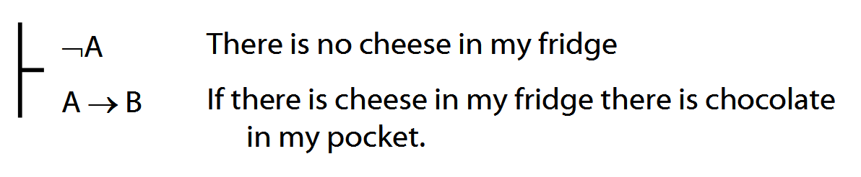
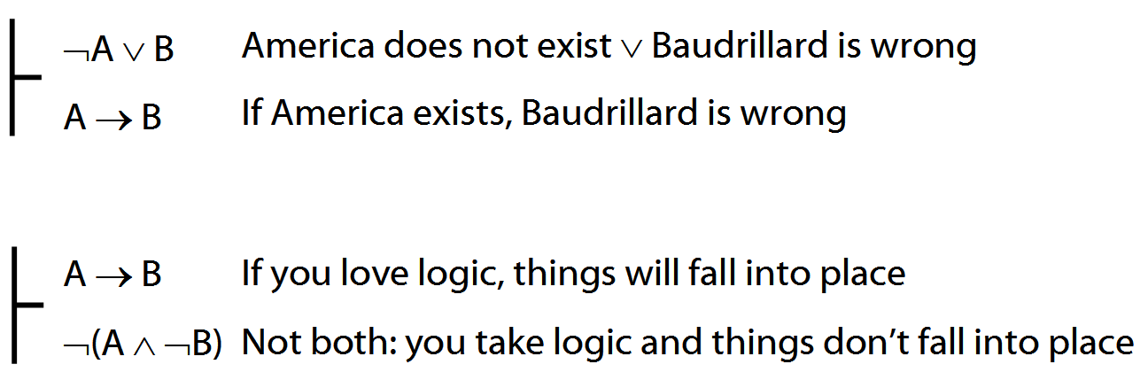
Quantifiers
Everything is broken: ∀x Broken(x)
Something is broken: ∃x Broken(x)
What does ∃ mean? We give the meaning of ∃ by specifying what it takes for a sentence containing ∃ to be true:
1. Give every object a name.
2. For each name in turn, create a new sentence like this: delete the quantifier and replace all instances of the variable it binds with that name
3. If ANY OF the new sentences are true, so is the original.

∃ and ∧ work together
Some object is F and G: ∃x ( F(x) ∧ G(x) )
I met a philosopher:
Some object is a philosopher and I met it:
∃x ( Philr(x) ∧ Met(a,x) )
Some square is blue: ∃x (Square(x) ∧ Blue(x))
Rooney scored a goal:
∃x (Goal(x) ∧ Scored(a,x))
Obama won an election:
∃x (Election(x) ∧ Won(a,x))
∀ and → work together
All my things are broken:
∀x (Belongs(a,x) → Broken(x))
Everything I do turns bad:
∀x ( Does(a,x) → TurnsBad(x) )
All squares are blue:
∀x ( Square(x) → Blue(x) )

Substitution of logical equivalents
Two sentences are logically equivalent when each is a logical consequence of the other.
φ ╡╞ ψ means φ and ψ are logically equivalent.
Terminology: let χ[ψ/φ] be the result of replacing φ with ψ
E.g. (Q¬¬∨P) [P/¬¬P] = Q∨P
Theorem: If φ ╡╞ ψ then χ ╡╞ χ[ψ/φ]

Exercises 05
For your fifth seminar
Only for fast groups
A. From the LPL textbook:
9.12–13
9.18–19 (trans.)
10.20, *10.24–7
10.28–9
13.2–3, 13.8–9 (quantifier proofs)
13.11, 13.13, 13.15
NEVER USE TAUT CON.
B. For each of the following sentences of FOL, give a logically equivalent sentence of idiomatic English using the specified interpretation. Your English sentences should be as concise as possible.
Domain : people and actions
D(x) : x is desirable
V(x) : x is virtuous
A(x) : x is an action
H(x) : x is a person
P(x,y) : x performed y
i. ∀x [ D(x) → V(x) ]
ii. ∀x [ [A(x)∧ D(x) ] → V(x) ] ]
iii. ∃x [ A(x) ∧ ¬[ D(x) → V(x) ] ]
*iv. ∃x ∀y [[[H(x) ∧ A(y)] ∧ P(x,y)] → V(y)]
**v. ¬∃x [∃y [H(x) ∧ P(x,y) ∧ A(y) ∧ ¬V(y)]
∧ ¬∃z[P(x,z) ∧ A(z) ∧ V(z)]]

